Mixed Unit Conversion
# Source: AI Source: Provided by: [Data Path: Persons Table -> ID Column: 1, Name_En Column: Motasem Essam] -> From: [ChatGPT] on [7/17/2026]
Mixed Unit Conversion is the process of converting measurements between different systems of units, such as SI (Metric) and Imperial/U.S. Customary, or converting between different types of units that measure the same physical quantity. Unlike conversions within a single system (e.g., meters to centimeters), mixed unit conversion requires using fixed conversion factors between different measurement systems.
Mixed unit conversion is widely used in engineering, international trade, manufacturing, aviation, medicine, construction, and scientific research, where different countries or industries use different unit systems.

Definition
# Source: AI Source: Provided by: [Data Path: Persons Table -> ID Column: 1, Name_En Column: Motasem Essam] -> From: [ChatGPT] on [7/17/2026]
Mixed Unit Conversion is the process of converting a measurement from one unit system or unit type to another equivalent unit while preserving the same physical quantity.

Purpose
# Source: AI Source: Provided by: [Data Path: Persons Table -> ID Column: 1, Name_En Column: Motasem Essam] -> From: [ChatGPT] on [7/17/2026]
Mixed unit conversion is used to:
- Compare measurements expressed in different unit systems.
- Facilitate international communication.
- Support engineering and scientific calculations.
- Standardize measurements in global projects.
- Convert historical or regional measurements into modern standards.

Characteristics
# Source: AI Source: Provided by: [Data Path: Persons Table -> ID Column: 1, Name_En Column: Motasem Essam] -> From: [ChatGPT] on [7/17/2026]
Mixed unit conversion:
- Converts between different measurement systems.
- Uses fixed conversion factors.
- Does not change the physical quantity.
- Often requires multiplication or division by constants rather than powers of 10.

Types of Mixed Unit Conversion

1. Metric ↔ Imperial Conversion
# Source: AI Source: Provided by: [Data Path: Persons Table -> ID Column: 1, Name_En Column: Motasem Essam] -> From: [ChatGPT] on [7/17/2026]
Converts between SI (Metric) and Imperial/U.S. Customary units.
Examples:
- Meters ↔ Feet
- Kilograms ↔ Pounds
- Liters ↔ Gallons

2. Metric ↔ U.S. Customary Conversion
# Source: AI Source: Provided by: [Data Path: Persons Table -> ID Column: 1, Name_En Column: Motasem Essam] -> From: [ChatGPT] on [7/17/2026]
Examples:
- Celsius ↔ Fahrenheit
- Kilometers ↔ Miles
- Liters ↔ U.S. Gallons

3. Different Unit Forms
# Source: AI Source: Provided by: [Data Path: Persons Table -> ID Column: 1, Name_En Column: Motasem Essam] -> From: [ChatGPT] on [7/17/2026]
Converting between units that represent the same quantity but use different scales.
Examples:
- Cubic meters ↔ Liters
- Square meters ↔ Square feet
- Newtons ↔ Pound-force (engineering)

Common Conversion Factors

Length
# Source: AI Source: Provided by: [Data Path: Persons Table -> ID Column: 1, Name_En Column: Motasem Essam] -> From: [ChatGPT] on [7/17/2026]
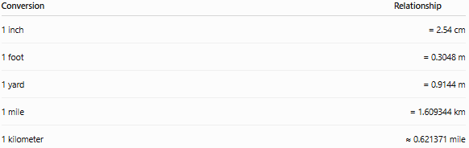
Conversion | Relationship
1 inch | = 2.54 cm
1 foot | = 0.3048 m
1 yard | = 0.9144 m
1 mile | = 1.609344 km
1 kilometer | ≈ 0.621371 mile

Mass
# Source: AI Source: Provided by: [Data Path: Persons Table -> ID Column: 1, Name_En Column: Motasem Essam] -> From: [ChatGPT] on [7/17/2026]
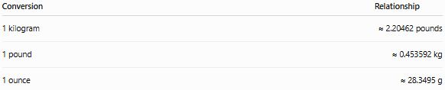
Conversion | Relationship
1 kilogram | ≈ 2.20462 pounds
1 pound | ≈ 0.453592 kg
1 ounce | ≈ 28.3495 g

Capacity
# Source: AI Source: Provided by: [Data Path: Persons Table -> ID Column: 1, Name_En Column: Motasem Essam] -> From: [ChatGPT] on [7/17/2026]
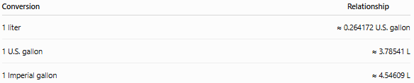
Conversion | Relationship
1 liter | ≈ 0.264172 U.S. gallon
1 U.S. gallon | ≈ 3.78541 L
1 Imperial gallon | ≈ 4.54609 L

Area
# Source: AI Source: Provided by: [Data Path: Persons Table -> ID Column: 1, Name_En Column: Motasem Essam] -> From: [ChatGPT] on [7/17/2026]
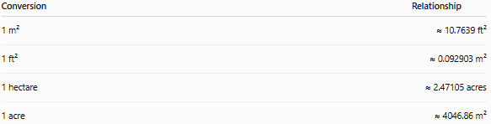
Conversion | Relationship
1 m² | ≈ 10.7639 ft²
1 ft² | ≈ 0.092903 m²
1 hectare | ≈ 2.47105 acres
1 acre | ≈ 4046.86 m²

Volume
# Source: AI Source: Provided by: [Data Path: Persons Table -> ID Column: 1, Name_En Column: Motasem Essam] -> From: [ChatGPT] on [7/17/2026]
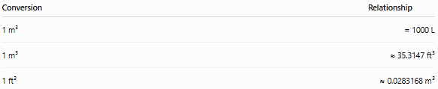
Conversion | Relationship
1 m³ | = 1000 L
1 m³ | ≈ 35.3147 ft³
1 ft³ | ≈ 0.0283168 m³

Temperature
# Source: AI Source: Provided by: [Data Path: Persons Table -> ID Column: 1, Name_En Column: Motasem Essam] -> From: [ChatGPT] on [7/17/2026]
Temperature conversion uses formulas rather than multiplication by a constant.
Celsius to Fahrenheit
$$F=\frac{9}{5}C+32$$
Fahrenheit to Celsius
$$C=\frac{5}{9}(F-32)$$
Celsius to Kelvin
$$K=C+273.15$$
Kelvin to Celsius
$$C=K-273.15$$

Examples
# Source: AI Source: Provided by: [Data Path: Persons Table -> ID Column: 1, Name_En Column: Motasem Essam] -> From: [ChatGPT] on [7/17/2026]
Example 1 – Length
Convert 5 meters to feet.
5 × 3.28084 = 16.4042 ft

Example 2 – Mass
Convert 10 kilograms to pounds.
10 × 2.20462 = 22.0462 lb

Example 3 – Capacity
Convert 2 liters to U.S. gallons.
2 × 0.264172 = 0.528344 gal

Example 4 – Temperature
Convert 25 °C to Fahrenheit.
$$F=\frac{9}{5}(25)+32={77}^{∘}F$$

General Conversion Formula
# Source: AI Source: Provided by: [Data Path: Persons Table -> ID Column: 1, Name_En Column: Motasem Essam] -> From: [ChatGPT] on [7/17/2026]
$$\boxed{\text{Converted Value}=\text{Original Value}×\text{Conversion Factor}}$$
or
$$\boxed{\text{Converted Value}=\frac{\text{Original Value}}{\text{Conversion Factor}}}$$
depending on the direction of conversion.

Applications
# Source: AI Source: Provided by: [Data Path: Persons Table -> ID Column: 1, Name_En Column: Motasem Essam] -> From: [ChatGPT] on [7/17/2026]
Mixed unit conversion is used in:
- Mechanical engineering
- Civil engineering
- Aerospace
- Automotive industries
- Medicine
- Manufacturing
- Surveying
- International trade
- Scientific research
- Everyday travel

Advantages
# Source: AI Source: Provided by: [Data Path: Persons Table -> ID Column: 1, Name_En Column: Motasem Essam] -> From: [ChatGPT] on [7/17/2026]
Mixed unit conversion:
- Enables international collaboration.
- Supports global engineering projects.
- Improves communication.
- Prevents misunderstanding of measurements.
- Allows comparison between different standards.

Limitations
# Source: AI Source: Provided by: [Data Path: Persons Table -> ID Column: 1, Name_En Column: Motasem Essam] -> From: [ChatGPT] on [7/17/2026]
Mixed unit conversion:
- Requires accurate conversion factors.
- May introduce rounding errors.
- Can cause mistakes if the wrong system is assumed.
- Temperature conversions require formulas instead of simple multiplication.

Common Mistakes
# Source: AI Source: Provided by: [Data Path: Persons Table -> ID Column: 1, Name_En Column: Motasem Essam] -> From: [ChatGPT] on [7/17/2026]
- Mixing Imperial and U.S. Customary units.
- Using approximate conversion factors when exact values are required.
- Forgetting to square or cube conversion factors for area and volume.
- Applying multiplication when division is required.
- Treating temperature like a linear scaling conversion without using the proper formula.

Key Points
# Source: AI Source: Provided by: [Data Path: Persons Table -> ID Column: 1, Name_En Column: Motasem Essam] -> From: [ChatGPT] on [7/17/2026]
- Mixed Unit Conversion converts measurements between different unit systems.
- It preserves the physical quantity while changing the unit.
- Most conversions use fixed conversion factors.
- Temperature conversions require conversion formulas.
- Area and volume conversions require squared or cubed conversion factors.
- Mixed unit conversion is essential in international engineering, science, manufacturing, and trade.

Conclusion
# Source: AI Source: Provided by: [Data Path: Persons Table -> ID Column: 1, Name_En Column: Motasem Essam] -> From: [ChatGPT] on [7/17/2026]
Mixed Unit Conversion is the process of converting measurements between different systems of units, such as SI (Metric) and Imperial/U.S. Customary, while preserving the same physical quantity. It relies on established conversion factors or mathematical formulas, particularly for temperature conversions. Because many industries and countries use different measurement systems, mixed unit conversion is an essential skill in engineering, manufacturing, science, medicine, international trade, and everyday applications, ensuring measurements remain accurate, consistent, and universally understood.

